**STAR** – Screening for Tuberculosis Using Artificial Intelligence in Remote Radiology facilities

**Need / Rationale –**

In Karnataka every year 8 lakh presumptive TB patients undergo sputum smear examinations and yet another 2 lakh presumptive undergo Rapid molecular testing for TB.

WHO recommends that before any confirmation of TB on NAAT it is ideal to screen the presumptive TB patients on X-ray. There are 75 CBNAAT and 101TruNAAT machines in the state deployed for this purpose.

However all the rapid molecular tests will be optimally utilized when the patient undergoes a screening test with the help of X-ray. There are approximately 507 X ray sites in the state in the public sector and most are not co located with Rapid molecular tests.

There are issues with X-ray reading in the periphery due to huge intra and inter observer Variations. Hence it is imperative to use a digital X -ray reading technology which can easily identify the abnormal X-rays and pin-point the signs of TB so that these selected X-rays can be then proposed for TB confirmation at NAAT sites.

The WHO guidelines also give a huge boost to computer-aided AI detection software as it can better interpret the digital X-rays, and triage suspected cases, more accurately than human X-ray readers. The new AI makes the screening process more efficient, and significantly reduces the time taken to make a diagnosis. This will ensure last mile connectivity and provide seamless screening of Presumptive TB patients via X-ray and further confirmation on NAAT.

When assessment was done on the need to use Artificial Intelligence under TB Program some of the key points which necessitated rationale to use of AI tools for screening X Rays are -

* District doesn’t capture Presumptive TB data base from all the diagnostic modalities, currently there is no mechanism to capture date from X Ray sites.
* High chances of missing Presumptive TB patients from X-ray sites
* Lack of streamlined mechanism of identification of abnormal X-rays
* Overdiagnosis of TB by using X-ray
* Both NTBPS and ACF findings have supported the evidence on the need of X-ray based screening prior to NAAT
* X-Ray screening using AI will be an asset in these unprecedented COVID times for TB Case finding.

NTEP program in State of Karnataka has come up with this new intervention called STAR – Screening for Tuberculosis Using Artificial Intelligence in Remote Radiology facilities which is partnership between State TB Office, Karnataka Health Promotion Trust (KHPT ) and Association of Public Health Technologists ( APT) with support from Qure AI and India Health Fund.

This AI tool developed by Qure AI which works on Analog X Ray screening is well suited to be used in remote facilities and it not only detects abnormal chest X-rays, but it can identify and localizes 29 common abnormalities in addition to screen for tuberculosis.

This solution provides a unique opportunity for the health sector, bringing efficiency, saving resources and bringing accuracy in interpretation and enhancing quality of service delivery.

Based on review of TB data available from Nikshay , districts which had higher diagnosis of TB using X-Ray modalities were identified and among them 5 districts namely Chikaballapur , Koppal , Bellary , Belgaum and Bagalkot were selected for Pilot implementation of AI based solution to screen X Rays for Tuberculosis. Data on TB Case detected using various diagnostic modalities is given below-

Public Sector-Basis of TB Diagnosis as X-ray

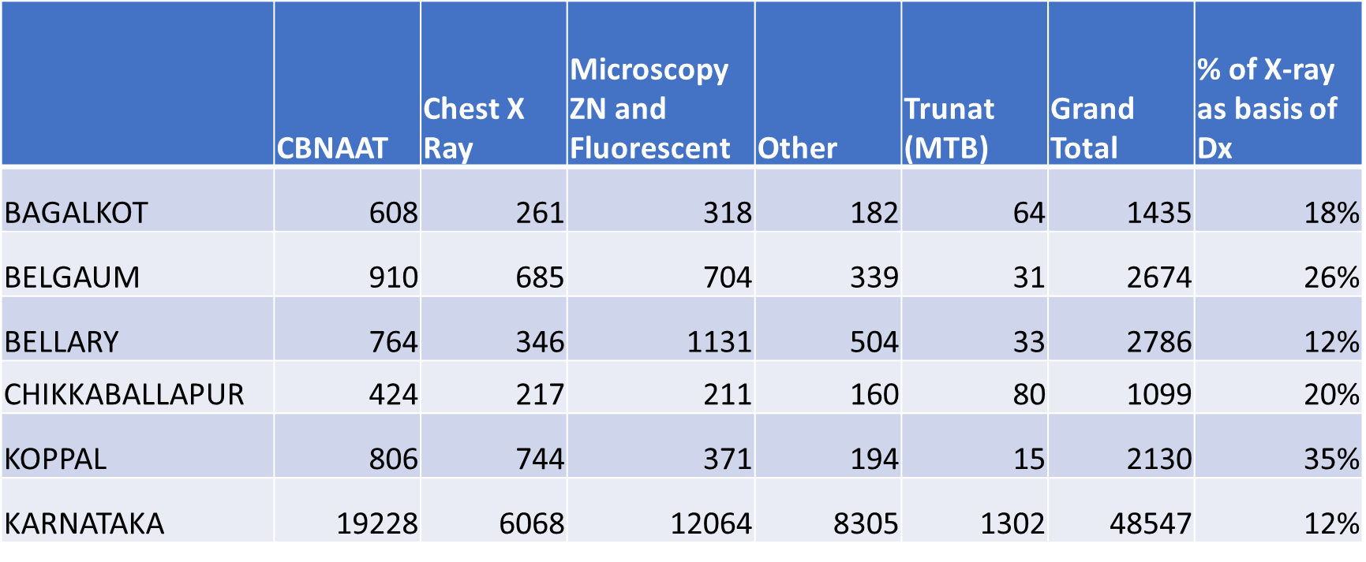

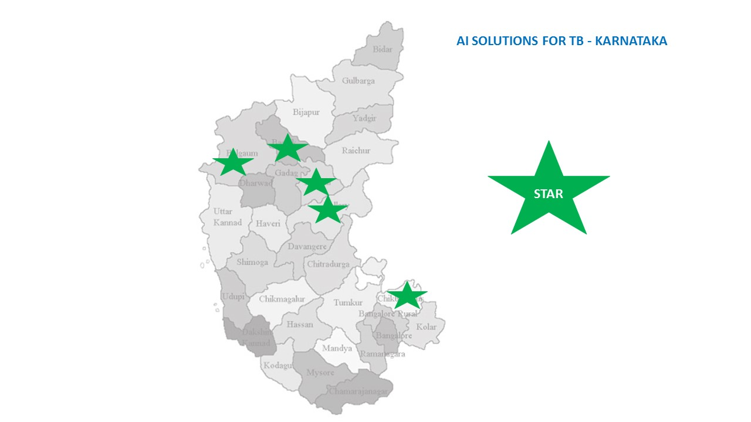

Districts Selected

From the above 5 districts as Phase -1 of the project, it was decided to implement AI solution in taluk hospitals where there is colocation of X Ray facility and easy access to CBNAAT testing. The following sites were selected from 5 districts –

 

**Description of the model –**

Many patients visit Hospitals in public healthcare system every day to seek healthcare and some of them are subjected to Chest X-Ray to rule out lung pathology. The current project makes use of this opportunity of large number of Chest X-Rays taken in hospitals to screen X-rays for signs suggestive of Tuberculosis by application of Artificial Intelligence tools with the overall goal of identifying Suspect TB X-Rays. Once Artificial Intelligence triages X-Ray as suggestive of Tuberculosis further escalation will be done where in patient sputum is collected and subjected to CBNAAT for confirmation.

Overview of qTrack AI solution –

qTrack is Qure.ai’s end-to-end, Artificial Intelligence (AI)-powered, automated disease management platform that has been developed to specifically provide healthcare professionals with a singular, holistic data gathering and reporting system, that maintains and manages all patient information in one place.

The qTrack app builds interactivity and connectivity between administrative managers, healthcare professionals, lab technicians and patients to help make data collection, transmission and recall a seamless process. This saves precious time which is otherwise lost locating and harmonizing data manually.



Its comprehensive offerings greatly benefit healthcare professionals. These include:

* Patient registrations
* Uploads of chest X-rays & scans
* Instant analysis processing using AI
* Automated reports
* Real-time patient monitoring; and
* Effective e care at community level

To adapt to technological challenges in remote areas, qTrack is built to accommodate and interpret analog chest X-rays as well. Photos of chest X-ray films clicked against a view box can be interpreted by directly uploading it from the healthcare worker’s phone’s gallery for processing.

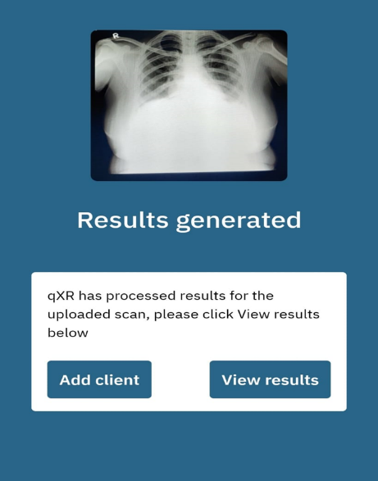

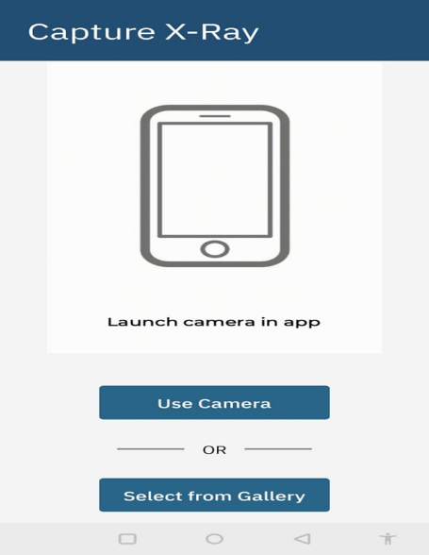

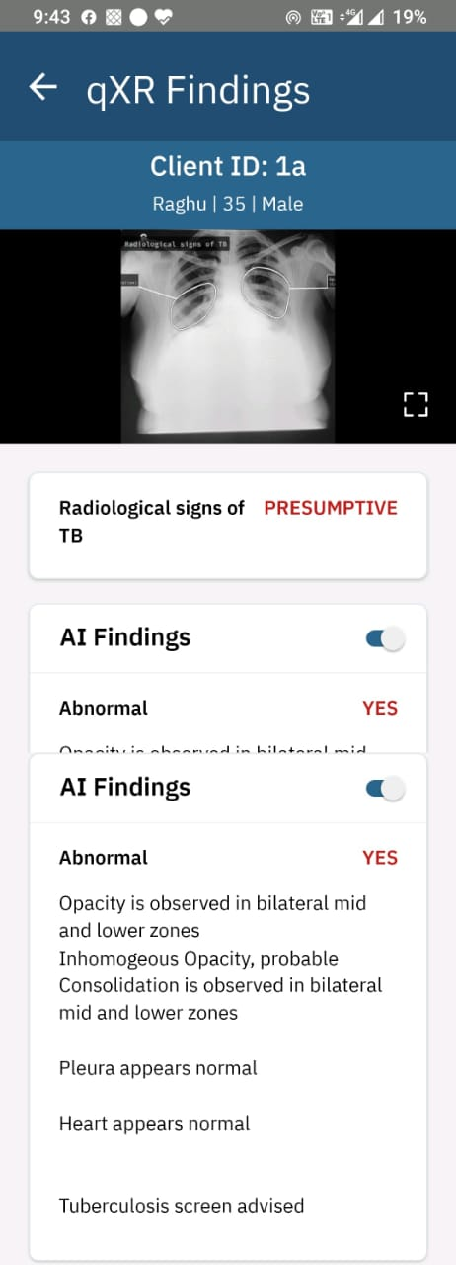

In addition qTrack helps management teams monitor daily activities across all locations of the healthcare provider in real-time. It uses intuitive dashboards to track overall activities, the scans performed, the number of cases identified on a daily basis and more. qTrack also enables the compilation of MIS reports for statistics across all activities, and for specific time periods which enable better forecasting and planning.

**Additional Strategies which will be started from month of November –**

Based on initial learnings from project it was felt there is a need to provide mentoring support to Doctors working in these identified sites to identify X-Rays where in CBNAAT has been negative but Artificial Intelligence has flagged X-ray as suggestive of Tuberculosis. In order to provide mentoring support medical colleges have been identified where in once in 15 days there will be online mentoring session from Respiratory Medicine specialists with focus on building capacity of doctors not to only to identify Signs of TB but to provide overall lung health care.

In addition AI Integrated Diagnostic Algorithm is developed which will be piloted in these 5 districts to guide the implementation, details of algorithm is given below –

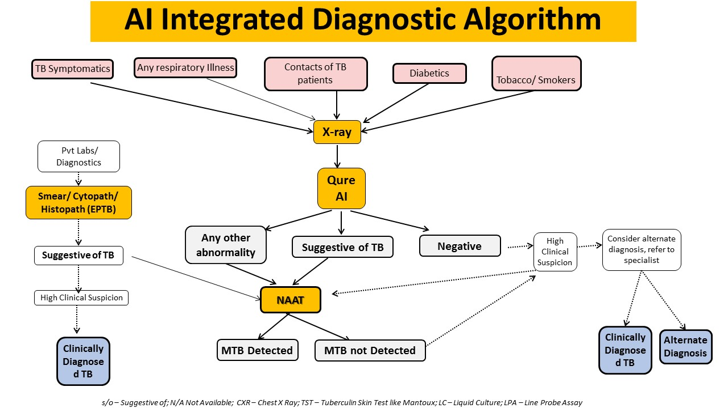

**Human Resources (Existing and / or New)**

The existing human resources available under NTEP at District level were used to implement the program where in staff would capture x –rays and upload it to qtrack App.

**Capacity building strategies, if applicable**

Once the sites were finalised District TB officers and District TB Staff were oriented about the project purpose and were trained on how to use the qtrack software. In addition all state TB Officers, District TB Officers and WHO Consultants were oriented on software and how to access data for program monitoring.

**Evidence from effectiveness**

The program was official launched on 7th of June 2021 and it was scaled up in phased manner to all 5 districts. Based on data available till date it can be seen AI has been helpful in identification of Tuberculosis by screening of X –Rays.

Total of 6361 X-Rays were subjected to AI analysis from these 5 districts out of which 1625 X-Rays were picked by AI as suggestive of Tuberculosis and 1145 X-Rays were picked as suggestive of lung pathology.

931 Out of 1625 X-Rays were subjected to CBNAAT and 185 were confirmed both by AI and CBNAAT as Tuberculosis giving positivity rate of 20%. In addition 17 (3%) of Tuberculosis cases were picked from those X-Rays which were marked as other lung abnormalities.

In addition use of Artificial Intelligence to screen X-Rays helped districts to identify other lung conditions ensuring overall lung health care to patients.

**Cost**

As this was joint partnership program between State TB Office, Karnataka Health Promotion Trust and Association of Public Health Technologists and main cost involved was towards use of software which came as support from Qure AI for giving free access to use of software in selected site.

Cost towards training of district staff in use of AI solution was jointly supported from State TB Office and Karnataka Health Promotion Trust. In case of future need for dedicated HR in high volume site in selected districts HR will be supported from Karnataka Health Promotion Trust.

**Summary of lessons and challenges**

Implementing AI based solution for first time under TB Program in remote radiology facility has given immense opportunity for learning. Although duration of project is less to assess the complete impact of AI based solution based on data available it has shown it could be potential tool not only for screening Tuberculosis but it can offer a complete lunch health solutions.

Some of the challenges which has been observed during implementation and which have direct impact on analysis of X-Rays by Artificial Intelligence tools are quality of X-Rays taken in radiology sites , Improper Uploading of X-Rays by healthcare worker in to qTrack App. In addition to this some of the other challenges identified are deputation of TB Healthcare worker to upload X-rays , time taken to upload X-Rays on real time basis in qTrack by health care worker , Availability of CBNAAT Cartridges for confirmation of cases .There is also a need to mentor doctors working in peripheral health system to diagnose Tuberculosis by X-Ray findings when CBNAAT is negative in order to prevent over / under diagnosis which indirectly could also help in providing overall lung healthcare

**Potential for Scale**

Approached currently used in this program on use of Artificial Intelligence for Screening X-Rays for TB has immense potential to scale as it works on Analog X-Rays. As availability of X-Rays are now scaled up to community health centre level , use of AI App Software qTrack directly by Doctor could guide them in better management of cases and help not only in effective diagnosis of Tuberculosis but provide overall lung health care.

As AI tools are also available in automated mode, a differential approach can be adopted wherein in high volume sites automated software option can be deployed and in low volume sites qtrack mobile based App can be given to doctors for direct screening and access to reports.

**Partners involved in implementation.**

The current program is partnership between State TB Office, Karnataka Health Promotion Trust and Association of Public Health Technologists with support from Qure AI and IHF.